Handout 1.13: Station Card, Sheet Pan Nachos with Salsa Bar
Lesson: 1.13 Lab 2 Print: One per station on card stock, both sides. Laminate if you can; it gets salsa on it. Give every student a paper copy on Day 1 to highlight their own steps.

Station ______ Sheet Pan Nachos with Salsa Bar
Serves 7. Time: 40 minutes. Oven: 400 degrees F, preheated by the teacher. Knives: none. Anything sharp: none. The teacher opens the oven. Nobody else.
Team names by role (first names only, written on Day 1): Head Chef ______________ Sous Chef ______________ Prep Cook ______________ Sanitation Lead ______________ Label Reader ______________ Runner ______________ Timekeeper and Safety Officer ______________

On the counter before we start (Head Chef checks the list, reports “station ready”)
- ☐ 1 bag tortilla chips, 13 oz (half a bag if the team is four or five)
- ☐ 1 cup shredded Mexican blend cheese (the Prep Cook measures it, or it is pre-measured)
- ☐ 1 can black beans, 15.5 oz, already opened by the teacher (use half)
- ☐ 1 can corn, 15.25 oz, already opened by the teacher (use one third)
- ☐ 1 sheet pan with 1 sheet of foil, pre-cut
- ☐ 1 colander, 1 dry measuring cup (1 cup), 1 large spoon, 1 spatula
- ☐ 2 oven mitts and 1 trivet (they stay on the counter the whole time)
- ☐ 7 plates, 7 forks, napkins
- ☐ Sanitizing spray and 2 cloths
- ☐ Everyone: hands washed, hair tied back, apron on, role card in hand

The 40 minutes
Minutes | Step | Who
0 to 5 | Wash hands, hair back, aprons. Station check. Head Chef reports “station ready.” | Everyone; Head Chef
5 to 10 | Line and layer. Foil in the pan, shiny side down, edges turned up. Chips in ONE even layer. You should see foil between some chips. Not a mountain. | Sous Chef; Runner brings chips and cheese
10 to 16 | Drain and top. Beans: pour into the colander at the sink, DRAIN AND RINSE under cold water, shake. Corn: DRAIN ONLY, do not rinse. Spread beans and corn over the chips. Cheese over everything, edge to edge. Head Chef checks the pan and calls “pan ready.” Sanitation Lead wipes the counter and puts the cans in the recycling. | Prep Cook; Sous Chef; Head Chef; Sanitation Lead
16 to 26 | Oven. The teacher takes the pan to the oven. 8 to 10 minutes at 400 degrees F. Runner and Timekeeper bring the salsa and sour cream from the refrigerator to the salsa bar. Everyone else sits at home base for the label discussion. Label Reader speaks for the station. Timekeeper calls “two minutes” at minute 24. | Teacher at the oven; Runner; Timekeeper; Label Reader; everyone
26 to 32 | Out and plate. The teacher puts the pan on YOUR trivet. One minute, hands off. Then the Head Chef portions with the spatula, about one seventh per plate. Runner takes the plates to the salsa bar, one station at a time, and serves: 2 tablespoons salsa, 2 tablespoons sour cream (that is one serving of each). Sanitation Lead fills the sink with hot soapy water. | Head Chef; Runner; Sanitation Lead
32 to 36 | Eat. Sit. Eat. Answer the question at your table: is this healthier than the bag it came from? Use the sodium number. | Everyone
36 to 40 | Clean and check. See the list below. Head Chef reports “station clean.” Teacher signs. | Sanitation Lead runs it; everyone cleans

The two oven rules (say them before we start)
- Only the teacher opens the oven. If your pan is done and the teacher is busy, you wait.
- The pan lands on the trivet and nobody touches it for one minute. The mitts stay by the trivet.

Clean and check (Sanitation Lead reads, everyone does, Head Chef reports)
- ☐ Foil rolled up and in the trash; pan washed, dried, and put away
- ☐ Colander, measuring cup, spoon, spatula washed, dried, put away
- ☐ Counter sprayed and wiped; nothing sticky
- ☐ Sink empty and wiped
- ☐ Mitts and trivet back where they live
- ☐ Plates and forks in the trash; napkins picked up off the floor
- ☐ Chairs in, aprons hung
Teacher signature: ______________________ Time: ______

Salsa bar (separate counter; stays cold until the pans go in)
Salsa (2 tablespoons is a serving, 220 mg sodium). Sour cream (2 tablespoons is a serving, 15 mg sodium). One station at the bar at a time. The Runner serves. Plates come to the bar; the bar does not come to the plates.
Traffic pattern (Runners draw it on Day 1):
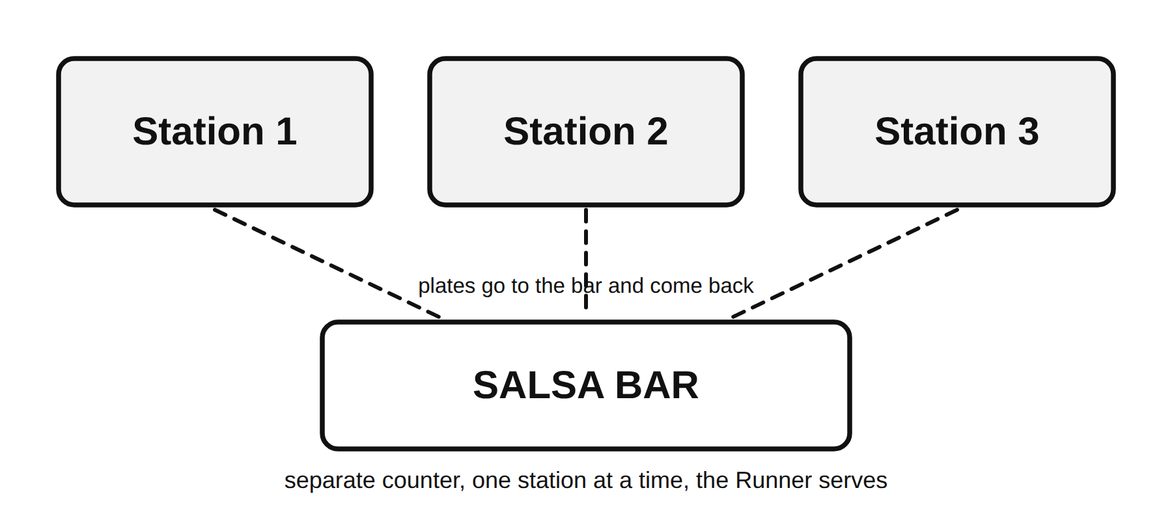
Three stations with the salsa bar on its own counter

Cold rule (from Lesson 1.2)
Salsa and sour cream live in the refrigerator until minute 16. The Runner brings them out when the pans go in and puts them back at minute 36. Nothing dairy sits on a counter for more than 20 minutes today.

Back of the card: the steps in Spanish
Store and circular used for pricing: ______________________ Dates: ______________ Cost per station: $______

